



**Digital Transformation in Product Engineering**

# **Foreword**

**The pace of innovation is accelerating more than ever before. New technologies and digitalization are rapidly transforming how businesses all over the world operate — and product development companies are no exception.**

With increasingly shorter lead times from conception to manufacturing, growing software content, constantly evolving customer demands, and fierce competition from new, tech-savvy players on the market, the pressure is on to always stay a step ahead. It won’t come as a surprise then that 39% of CEOs have placed digital transformation as the top priority for their CIOs ([**CIO, 2020**](https://cdn2.hubspot.net/hubfs/1624046/2020%20State%20of%20the%20CIO%20Executive%20Summary_Final.pdf)).

Although it may seem daunting, digital transformation also presents huge opportunities for product development companies. Opportunities to stand out compared to the competition, and in the process, revolutionize how new products are designed, developed, and launched. ►

## **“Digital transformation is much more than just a change in IT technology such as hardware, software, or a digital platform. A digital transformation goes to the heart of the business processes and transforms them to leverage digital capabilities that were unavailable during the**

**industrial age.”**

– The Institute for Digital Transformation



From agile ways of working to IoT, 3D printing, rapid prototyping, all the way to leveraging AI and machine learning for research, testing, and customer identification, digital transformation is having a huge impact on the field of product development. With R&D becoming more iterative and integrated all the time, the product development discipline is adapting at lightning speed to feedback from the market and users.

While digital transformation does bring new opportunities and significant benefits, it doesn’t come without its own challenges. This eBook will explore the following themes and their impact onthe field of product engineering:

# **1 2 3**

**Read on to learn more about the impact of digital transformation on**

**The evolution of the market landscape**

**New product development methods**

# **4 5**

**Challenges of integrating development streams**

**product development, the opportunities for innovation, and tips for**

**overcoming the tricky**

**The importance of smooth collaboration**

**Processes and tooling to facilitate**

**tr**

**ansformation**

**challenges that come along with it.**

# **The evolution of the market**

**From new ways of working to innovative technologies that products are imbued with, the product development market is constantly shifting and evolving. Here are three overarching trends that are shaping the future of new product development:**

1. **From hardware to software (and sometimes, back again)**

Due to the growing software content of smart, connected products, it’s becoming a requirement to integrate hardware and software streams in product development.

Interestingly, while incumbents are busy ramping up software development capabilities, new market players are

bridging the gap the other way around by entering the product hardware space to add more value to their software offering. The key takeaway? Integrated (even while distributed) teams that deliver end-to- end solutions are the future of product development.

1. **A new era of client focus and collaboration**

Razor-sharp client focus and relationship management have jumped to the forefront of product development. Mass customization requires developers to build a number of tailor-made variants.

In the meantime, customers also want to connect with their products and related communities before, during, and after using them, as well as integration with other digital platforms so that they can access them remotely. In order to create products that serve user needs

seamlessly, their feedback is needed right from the start (as well as throughout) the end-to-end design and manufacturing process.

1. **Delivering consistent value is key**

Industrial age businesses could create a product and have it dominate the market for long periods of time with little to no changes. Digital products face much more competition and demands that evolve faster than that. Customers have come to expect a constant stream of new features, updates, and upgrades – made possible by more and more software.

In order to consistently deliver value to customers, teams need to run like well- oiled machines. This requires a smooth product development process. Speed to market is often why enterprise leaders undertake digital transformation journeys and implement Agile ways of working.

# **Adapting product delivery methods**

**Before diving into new product development methods, let’s take a step back and examine where it all started.**

Traditional new product development (also known as NPD) typically followed the Waterfall model. Requirements and specifications were exhaustively determined upfront, resources were estimated and budgeted, and a list of tasks was created that the development team needed to complete in order, without skipping ahead or working in parallel. In practice, the sequential cascade of development phases looks a lot like this:

**Maintenance**

**Design**

**Requirements**

**Testing**

**Implementation**

The downside of this development model is that it creates dependencies that slow down time to market. They also make it hard to adapt to unexpected challenges, and oftentimes, companies that use this model end up with a product that is not totally satisfactory to the customer because their feedback was not incorporated throughout the process.

**Source:** [**ntaskmanager.com**](https://www.ntaskmanager.com/blog/how-to-use-ntask-for-waterfall-project-management-a-practical-guide-for-first-timers/)

# **New product development methods**

**This traditional Waterfall process has been reimagined for the digital age, resulting in the creation of Agile methodologies. Agile and hybrid development methodologies promote:**

1. 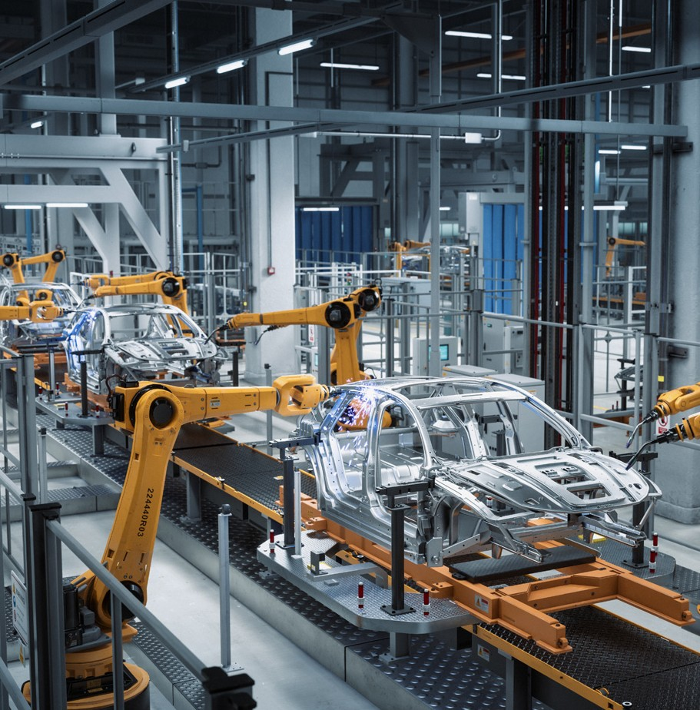Close client collaboration, incorporating customer feedback throughout the process
2. Cross-functional, self-organizing teams
3. Flexible scope redefinition throughout the project
4. Iterative development sprints that allow teams to provide value more consistently, quickly, and safely
5. Continuous learning, improvement, and process optimization

As a result of implementing Agile ways of working, companies can respond much faster to new opportunities, manage shifting market and user demands, and stay competitive in an increasingly tough business ecosystem.

On top of that, many innovative technologies are also disrupting and revolutionizing the way product development methods are carried out, like:

* + The use of artificial intelligence and machine learning to help

with research, testing, predictive analytics

* + Computer-aided design programs to

accelerate concepting and prototyping

* + Augmented and Virtual Reality simulators for testing products that haven’t even been created yet
  + Robotic assembly lines
  + Embedded software and IoT for smart, connected devices and data collection.

# **Integrating parallel development streams**

**Traditionally, there has always been a bit of tension between hardware and software teams. Something along the lines of an “us and them” mentality.**

While there are similarities between what the two teams do (and plenty of overlap) it’s naturally the differences that present the main challenges for creating “fused” teams. Here are some of the main differences which can be challenging when it comes to integrating hardware and software development efforts:

1. **Development time**

One of the trickiest issues when it comes to aligning hardware and software development efforts is the average time it takes to create these different components. Hardware inevitably takes longer than software to produce, but software cannot wait for hardware anymore. In the past, software development would begin when

a reliable version of the hardware was available. Nowadays, with much shorter lead times and demanding market conditions, software development needs to start much sooner and run in parallel with hardware engineering. However, creating a piece of hardware still takes months or even years, depending on what the piece is for and how complex it is.

1. **Change flexibility**

As you can imagine, it isn’t as easy (or as cheap) to update or change hardware as it is to change software. Hardware products are physical objects which cannot just be tweaked after they’ve been manufactured — developers need to go through the whole process again to create a new version. And in order to update hardware to be able to handle new features, it often takes up to 8 weeks because of the time it takes to collect feedback, source necessary parts, manufacture, test, and order new pieces again.

This makes it extremely tricky to keep both processes on track, especially since software is often changed and updated every two weeks or so. This dependency can create significant delays in the whole process.

1. **Planning and budgeting**

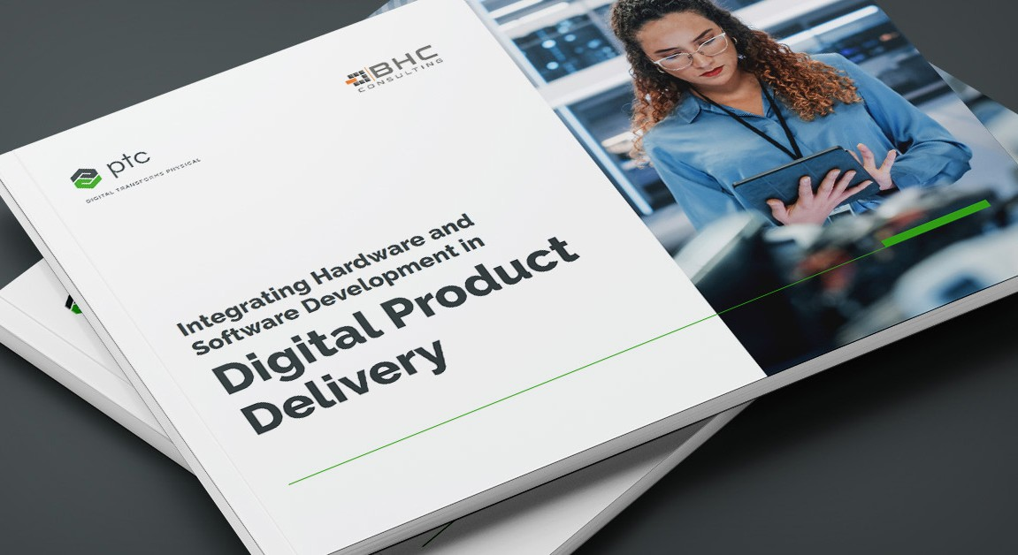

[**Integrating Hardware and Software Development in Digital Product Delivery**](https://content.intland.com/integrating-hardware-and-software-development-in-digital-product-delivery)

[**Download this white paper by BHC experts to see how rethinking ALM and PLM can help unify parallel development streams!**](https://content.intland.com/integrating-hardware-and-software-development-in-digital-product-delivery)

[**Download eBook**](https://content.intland.com/integrating-hardware-and-software-development-in-digital-product-delivery)

Hardware and software cost models are quite different, which affects planning, budgeting, and the process of getting stakeholder buy-in.

The costs of software development are pretty constant over time, and typically increase all of a sudden towards the end of the development cycle. Hardware costs are usually higher and fluctuate more throughout the course of a project depending on the complexity of the product and how readily available materials are.

This makes balancing cash flow and necessary resources more complex for hardware teams and businesses, since they have to worry about things like deadstock (items that won’t be used or sold) while software teams only really need to be concerned with the cost of team resources, marketing operations, and

necessary tools.

1. **Project management**

Project management is typically more complicated for hardware product managers than their software equivalent. Or at the

very least, they tend to have more responsibilities and areas to coordinate than software teams do: electronics engineering, mechanical engineering, product assembly, packing, shipping, and more.

There are also key differences in product development methodologies used. Hardware teams still often use a Waterfall approach, even if their products contain embedded software, while software teams usually use the V-model or Agile methodologies.

This disparity in methodologies makes it tricky to get both teams on the same page and align their development efforts, but it is possible with a good deal of organization, supportive tooling, and a significant mindset shift.

# **The collaboration challenge**

**Product engineering teams, especially those working in highly regulated industries like medical device manufacturing, automotive, and aerospace, for example, need to run like well- oiled machines in order to produce the highest quality (and safest) products possible for the public.**

On top of that, rigorously controlled operations and documentation are vital for compliance and regulatory reasons. That being said, with distributed remote teams collaborating all over the world, new methodologies to implement, and a plethora of tools to get on board with, it is harder than ever to ensure smooth collaboration.

Some of the key collaboration challenges product development teams face when trying to increase their speed-to-market and customer-focused product development are the following:

**Working in silos**

**Lack of stakeholder buy-in**

**1**

**2**

**Not having clearly defined roles**

**3**

**Prioritizing technical know-how over customer feedback**

**4**

**Legacy tooling**

**5**

# **The right tooling makes all the difference**

**Collaborating effectively throughout the end-to-end process of creating complex, digital products is no easy feat.**

**Consumer-grade collaboration tools**

**Traditional requirements management platform**

**Modern integrated Application Lifecycle Management platforms**

That being said, there are many tools out there that support effective software development, but many companies

are still using legacy software, even in safety-critical industries like MedTech, automotive, and aerospace companies.

So what are your options if you’re ready to take the leap from legacy tooling to Agile working methods and need a platform to support your journey?

Let’s take a quick look:

## **Examples**

**Advantages**

**Disadvantages**

Email, word documents, spreadsheets

Often free, easy to use, uncomplicated implementation

Prone to human error, lack of visibility and traceability, endless version trees and email chains. Need to use alongside an RM platform

Legacy software like IBM DOORS®

Software maturity,

name-brand recognition, commonly used thus familiar

Poor data integrity, lacking traceability and transparency, little flexibility for innovation

and improvement. Need to use alongside other collaboration tools

 

Improved collaboration, productivity and transparency, easy audit trails, cost & time saving

Requires more of an upfront investment, transitioning and implementation can take longer at first, but after stabilization the resources saved are measurable

# **Closing thoughts**

**Digital transformation is relentlessly revolutionizing the way we create new products and bring them to market.**

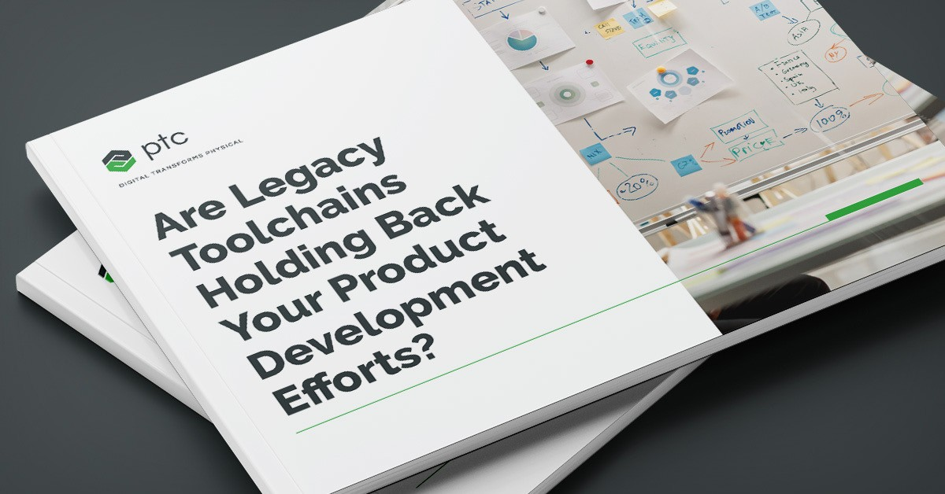

[**Are Legacy Toolchains Holding Back Your Product Development Efforts?**](https://content.intland.com/are-legacy-toolchains-holding-back-your-product-development-efforts)

[**Download this eBook to learn more about popular strategies for modernizing legacy systems!**](https://content.intland.com/are-legacy-toolchains-holding-back-your-product-development-efforts)

With a never-ending stream of market demands, increasingly shorter lead times, and a fiercely competitive economy, product development companies have their work cut out for them.

But digitalization brings many new opportunities for growth and differentiation,

as well as the challenges which need to be tackled throughout the process. The right tooling can help smooth collaboration, promote Agile ways of working, and even facilitate compliance.

**Sources:** [**2020 State of the CIO Executive Summary**](https://cdn2.hubspot.net/hubfs/1624046/2020%20State%20of%20the%20CIO%20Executive%20Summary_Final.pdf) **/** [**8 Ways Digital Transformation is Changing New Product**](https://blogs.babson.edu/leadership/2017/06/16/8-ways-digital-transformation-is-changing-new-product-development/)[**Development**](https://blogs.babson.edu/leadership/2017/06/16/8-ways-digital-transformation-is-changing-new-product-development/) **/** [**Digital Transformation in Product Development**](https://www.institutefordigitaltransformation.org/digital-transformation-in-product-development/) **/** [**Digital Transformation and Its Impact on**](https://innovationmanagement.se/2020/03/11/digital-transformation-and-its-impact-on-new-product-management-for-manufacturers/)[**New-Product Management for Manufacturers**](https://innovationmanagement.se/2020/03/11/digital-transformation-and-its-impact-on-new-product-management-for-manufacturers/) **/** [**Digital Transformation in Quality and Regulatory Operations**](https://www.institutefordigitaltransformation.org/digital-transformation-in-quality-and-regulatory-operations/)[**Hardware VS Software Development: Similarities And Differences**](https://aduk.de/industry-news/hardware-vs-software-development-similarities-and-differences/) **/** [**The 5 biggest connected product**](https://www.accenture.com/us-en/blogs/industry-digitization/the-5-biggest-connected-product-development-trends)[**development trends**](https://www.accenture.com/us-en/blogs/industry-digitization/the-5-biggest-connected-product-development-trends) **/** [**The Power of Developing Hardware and Software in Parallel**](https://www.design-reuse.com/articles/31951/the-power-of-developing-hardware-and-software-in-parallel.html)

**DIGITAL TRANSFORMATION IN PRODUCT ENGINEERING**



[**Start Trial**](https://content.intland.com/blog/introduction-to-arp4754)

[**Try Codebeamer now Start your free 30-day trial of Codebeamer in minutes:**](https://www.ptc.com/en/products/codebeamer)



121 Seaport Blvd, Boston, MA 02210 : ptc.com

**© 2023, PTC Inc. All rights reserved. Information described herein is furnished for informational use only, is subject to change without notice, and should not be taken as a guarantee, commitment, condition or offer by PTC. PTC, the PTC logo, and all other PTC product names and logos are trademarks or registered**

**trademarks of PTC and/or its subsidiaries in the United States and other countries. All other product or company names are property of their respective owners.**

**019-digital-transformation-in-product-engineering-02-10**